# JS Advanced Retake Final Exam

# Problem 1. Furniture Store

**Environment Specifics**

Please, be aware that every JS environment may **behave differently** when executing code. Certain things that work in the browser are not supported in **Node.js**, which is the environment used by **Judge**.

The following actions are **NOT** supported:

* **.forEach()** with **NodeList** (returned by **querySelector()** and **querySelectorAll()**)
* **.forEach()** with **HTMLCollection** (returned by **getElementsByClassName()** and **element.children**)
* Using the **spread-operator** (**...**) to convert a **NodeList** into an array
* **append()** in Judge (use only **appendChild()**)

If you want to perform these operations, you may use **Array.from()** to first convert the collection into an array.

**Use the provided skeleton to solve this problem.**

**Note**: You **can't** and you have no permission to **change** directly the given html code (index.html file).

**Write the missing JavaScript code** to make the **Furniture** **Store** work as expected:

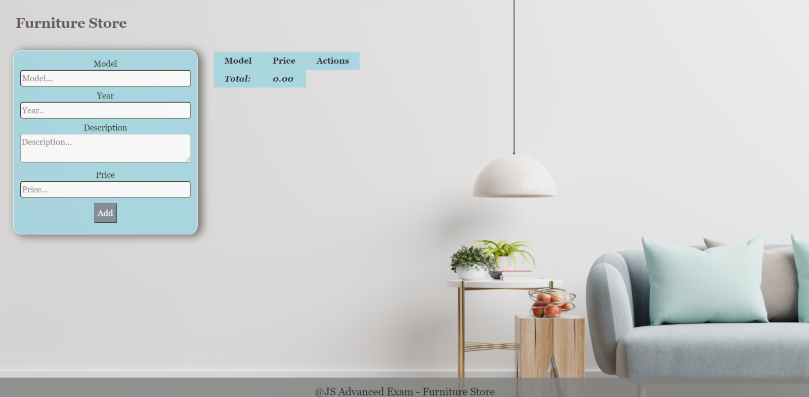

**Your Task**

* A**ll fields (model, year, description, and price)** are **filled with the correct input**
  + **Model and description** are **non**-**empty** **strings**
  + **Year** and **Price** need to be **positive** **numbers**
  + **All fields must be filled**

1. **Getting the furniture information**

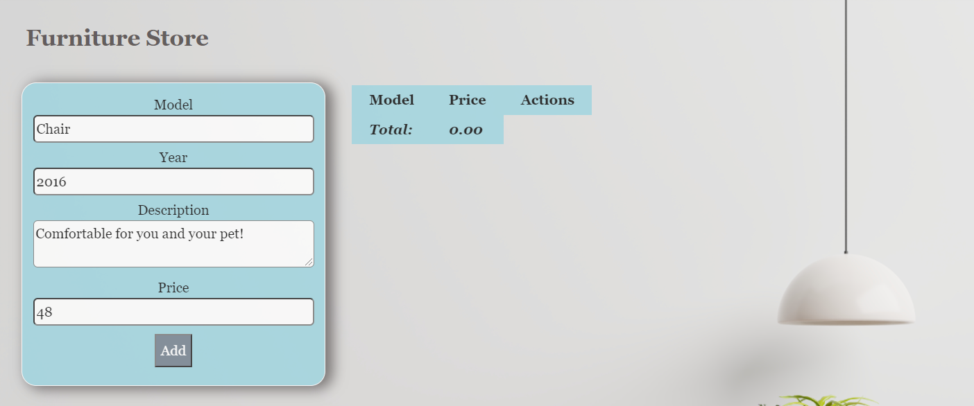

* When you click the “Add” button, the information from the input fields must be added to the table and then clear input fields.
* The table contains **Model, Price of furniture** and **Actions** - **[More information], [Buy it]**. **Price** must be **rounded** to **second** digit after decimal point.

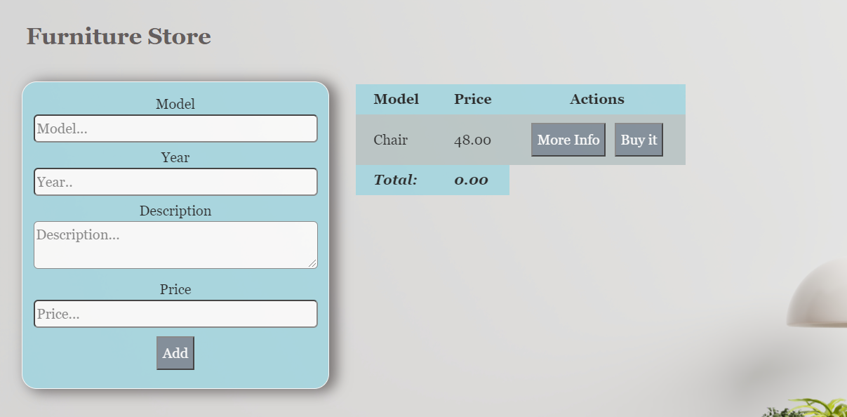

**Each furniture** must be appended to **"furniture-list"** and look like the picture below: 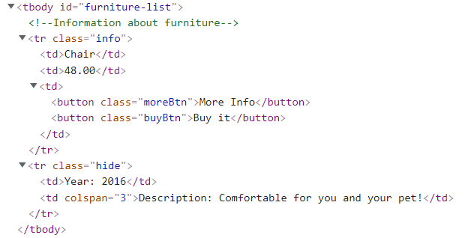

Each furniture has main information line **(Model, Price)** and an additional information line. The additional information line stores **the description and year** of manufacture of the furniture **(hidden until the "More info" button is pressed**)**.**

When the **"More Info"** button is clicked, change button text from **"More Info"** to **"Less Info"** and style display of **"class = hide"** from **"none "** to **"contents".** The second **<td>** must have attribute **colspan** with value **3.** When click **"Less Info"** button is clicked, change button text from **"Less Info"** to **"More Info"** and style from **"contents "** to **"none".**

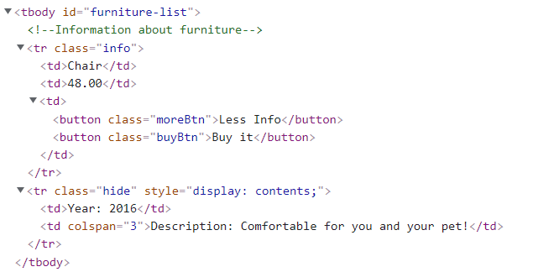

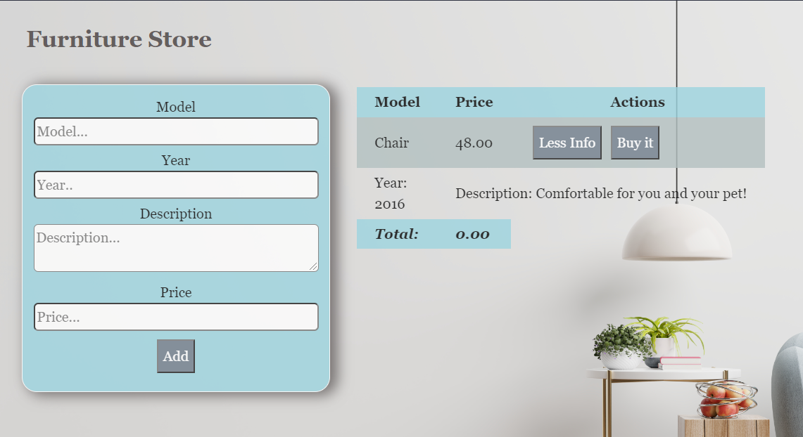

When the **"Buy it"** button is clicked, should have the following **functionality:**

* **The current furniture** must be **removed from the row** in the table
* You need to **change** the **total** profit in **the store.** Take the element with class **"total-price"** **and increase the current total price** **with** the **price of the furniture**.

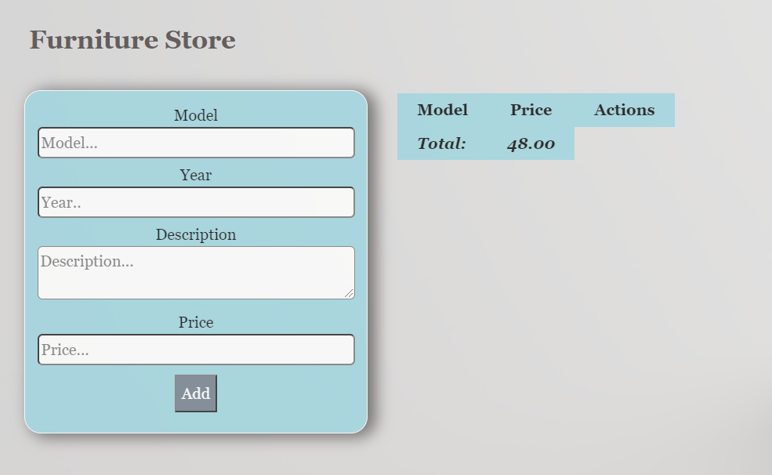

**Submission**

Submit only yours **solve()** function.

*GOOD LUCK… (:*

window.addEventListener('load', solve);

function solve() {

    let modelInputElement = document.getElementById('model');

    let modelInput = modelInputElement.value;

    let yearInputElement = document.getElementById('year');

    let yearInput = yearInputElement.value;

    let descriptionInputElement = document.getElementById('description');

    let descriptionInput = descriptionInputElement.value;

    let priceInputElement = document.getElementById('price');

    let priceInput = priceInputElement.value;

    let addButton = document.getElementById('add');

    addButton.addEventListener('click', (e) => {

        e.preventDefault();

        if (modelInputElement.value !== ''

            && modelInputElement.value !== undefined

            && descriptionInputElement.value !== ''

            && descriptionInputElement.value !== undefined

            && yearInputElement.value > 0

            && priceInputElement.value > 0) {

            let tableBodyElement = document.getElementById('furniture-list');

            let tableRowElement = document.createElement('tr');

            tableRowElement.classList.add('info');

            let tableTDElement = document.createElement('td');

            tableTDElement.textContent = modelInputElement.value;

            let tableTD2Element = document.createElement('td');

            let actualValue = Number(priceInputElement.value);

            let finalValue = actualValue.toFixed(2);

            tableTD2Element.textContent = finalValue;

            let tableTD3Element = document.createElement('td');

            let moreInfoButton = document.createElement('button');

            moreInfoButton.classList.add('moreBtn');

            moreInfoButton.textContent = 'More Info';

            moreInfoButton.addEventListener('click', moreInfoHendler);

            let buyButton = document.createElement('button');

            buyButton.classList.add('buyBtn');

            buyButton.textContent = 'Buy it';

            buyButton.addEventListener('click', buyHendler);

            tableTD3Element.appendChild(moreInfoButton);

            tableTD3Element.appendChild(buyButton);

            tableRowElement.appendChild(tableTDElement);

            tableRowElement.appendChild(tableTD2Element);

            tableRowElement.appendChild(tableTD3Element);

            tableBodyElement.appendChild(tableRowElement);

            modelInputElement.value = '';

            yearInputElement.value = '';

            descriptionInputElement.value = '';

            priceInputElement.value = '';

        }

        function moreInfoHendler(e) {

        }

        function buyHendler(e) {

        }

    });

}